**Practical No :-1**

**Aim:-**Write a program to create a robot

i) With gear ii) Without gear

and move it forward, left, right .

**Program:-**

**i ) With gear :-**

**Movewithgear.java**

import ch.aplu.robotsim.*;

class Movewithgear

{

Movewithgear()

{

NxtRobot robot = new NxtRobot();

Gear gear = new Gear();

robot.addPart(gear);

gear.forward(2000);

gear.setSpeed(30);

gear.left(480);

gear.forward(2000);

gear.right(480);

gear.forward();

robot.exit();

}

public static void main(String[] args)

{

new Movewithgear();

}

}

**Output :-**

**Initial state :- Move Forward:**

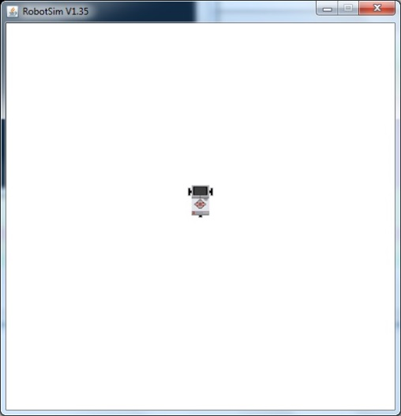 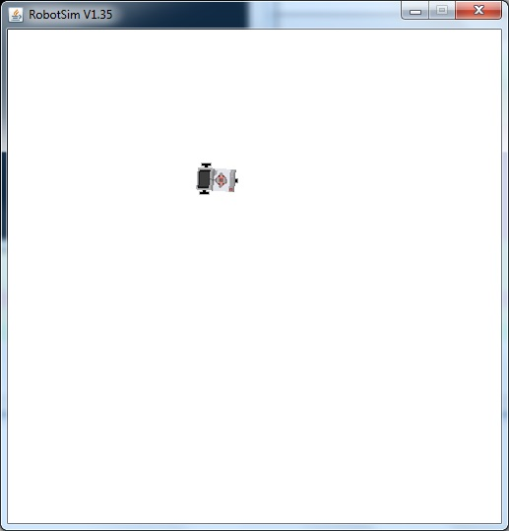

**Turn left :-**

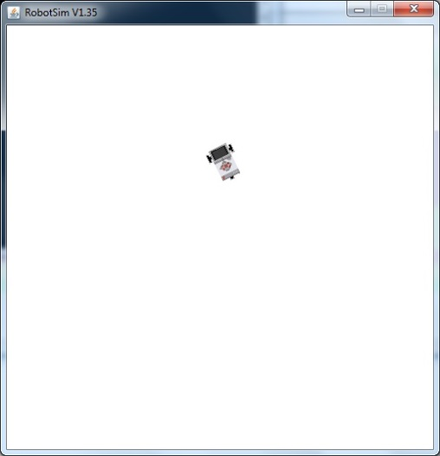

**ii ) Without gear :-**

**Movewithoutgears.java**

import ch.aplu.robotsim.*;

class Movewithoutgear

{

Movewithoutgear()

{

TurtleRobot robot = new TurtleRobot();

robot.forward(100);

robot.left(90);

robot.forward(50);

robot.right(90);

robot.forward(50);

robot.exit();

}

public static void main(String[]args)

{

new Movewithoutgear();

}

}

**Output :-**

**Initial state :- Turn left :-**

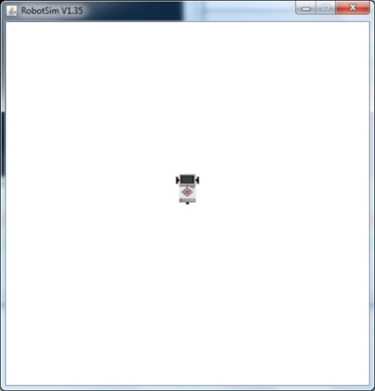 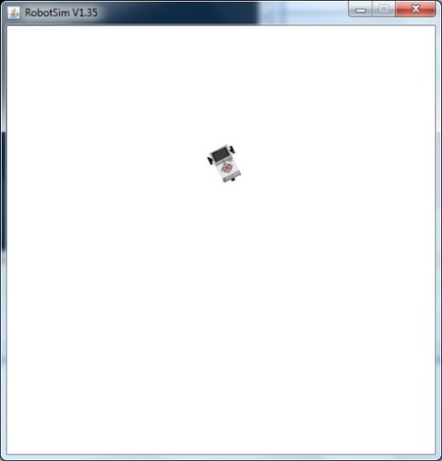

**Move Forward :-**

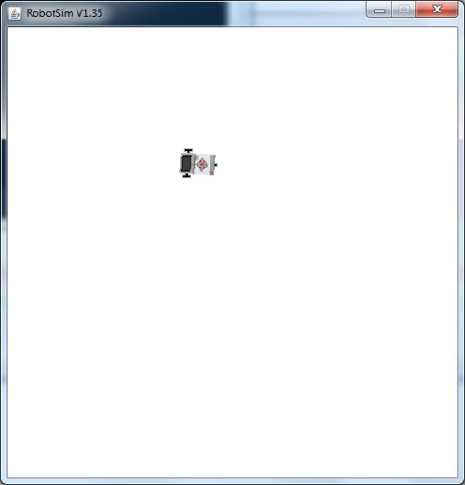

**Practical No :-2**

**Aim:-**Write a program to create a robot with two motor and move it forward, left and right .

**Program :-**

**MovewithMotors.java**

import ch.aplu.robotsim.*;

public class Movewithmotors

{

public Movewithmotors()

{

NxtRobot robot = new NxtRobot();

Motor motA = new Motor(MotorPort.A);

Motor motB = new Motor(MotorPort.B);

robot.addPart(motA);

robot.addPart(motB);

motA.forward();

motB.forward();

Tools.delay(2000);

motA.stop();

Tools.delay(1050);

motA.forward();

Tools.delay(2000);

motB.stop();

Tools.delay(1050);

motB.forward();

Tools.delay(2000);

robot.exit();

}

public static void main(String[]args)

{

new Movewithmotors();

}

}

**Output :-**

**Initial state :- Turn right :-**

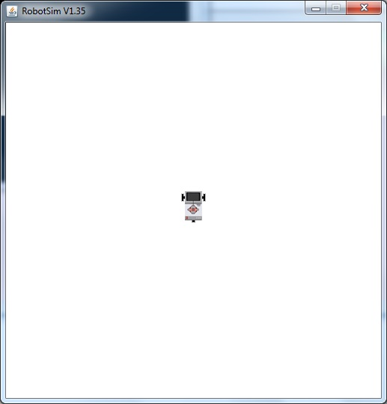 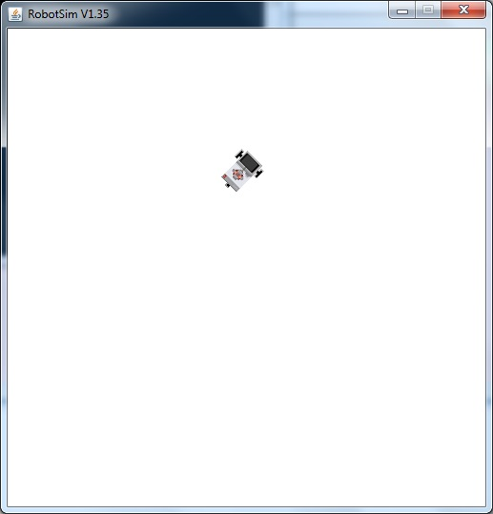

**Move Forward :- Final state :-**

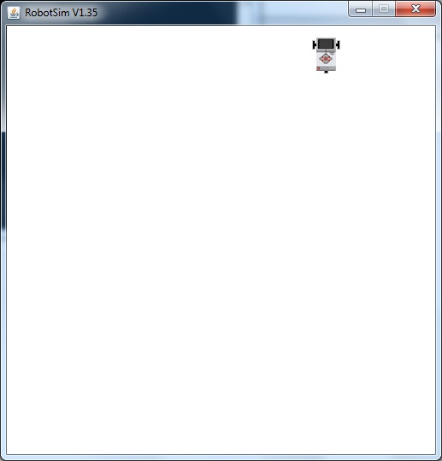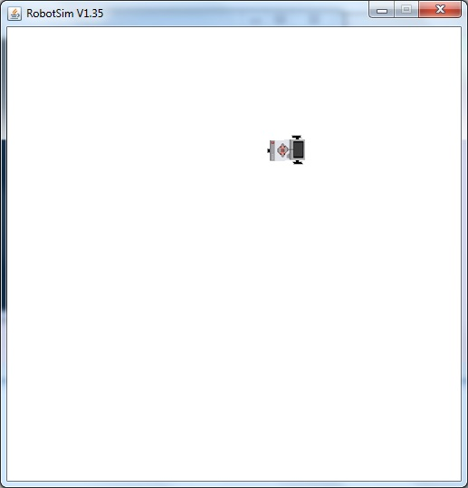

**Practical No :-3**

**Aim :-**Write a program to create a robot with light sensors to follow a line .

**Program :-**

**LineFollower.java**

import ch.aplu.robotsim.*;

class LineFollower

{

LineFollower()

{

LegoRobot robot = new LegoRobot();

Gear gear = new Gear();

LightSensor ls = new LightSensor(SensorPort.S3);

robot.addPart(gear);

gear.setSpeed(50);

robot.addPart(ls);

while(true)

{

int v = ls.getValue();

if(v<100)

gear.forward();

if(v>300 && v<750)

gear.leftArc(0.05);

if(v>800)

gear.rightArc(0.05);

}

}

public static void main(String[]args)

{

new LineFollower();

}

static

{

RobotContext.setStartPosition(50,490);

RobotContext.setStartDirection(-90);

RobotContext.useBackground("sprites/road.gif");

}

}

**Output :-**

**Initial state :- Intermediate state :-**

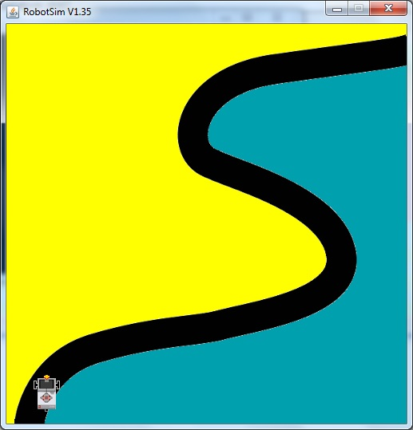 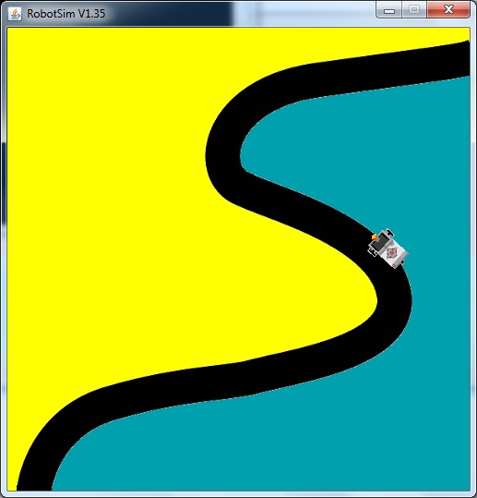

**Final state :-**

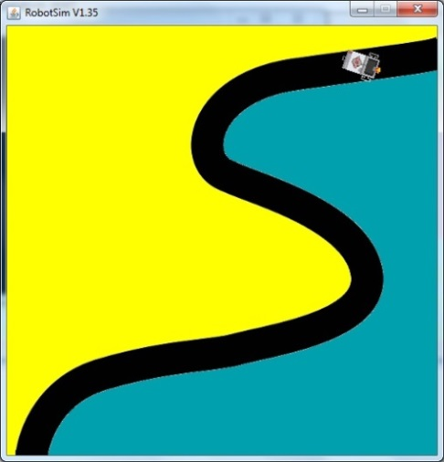

**Practical No :-4**

**Aim :-**Write a program to create a robot that does a circle using 2 motors .

**Program :-**

**Circlem.java**

import ch.aplu.robotsim.*;

class Circlem

{

Circlem()

{

NxtRobot robot=new NxtRobot();

Gear gear=new Gear();

robot.addPart(gear);

gear.setSpeed(200);

gear.leftArc(0.2,7000);

gear.rightArc(0.2);

Tools.delay(5000);

robot.exit();

}

public static void main(String[]args)

{

new Circlem();

}

}

**Output :-**

**Initial state :-**

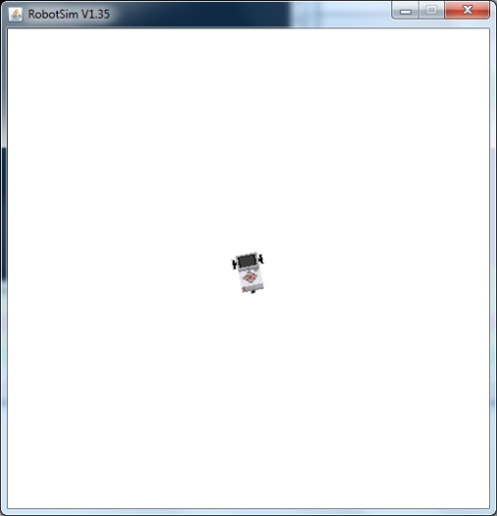 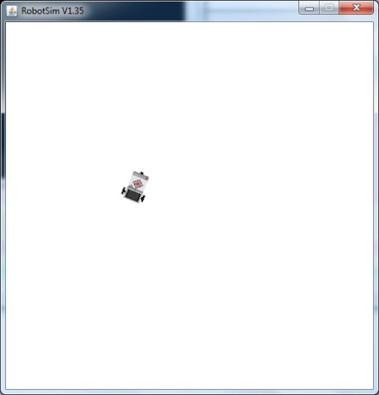

**Intermediate state :- Final state :-**

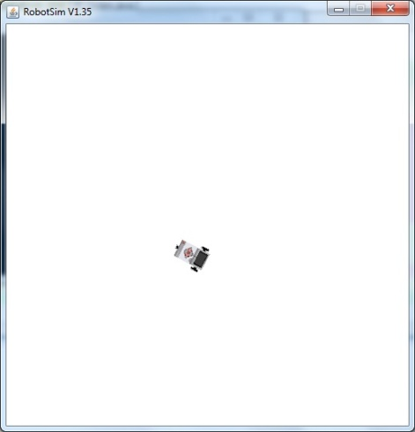 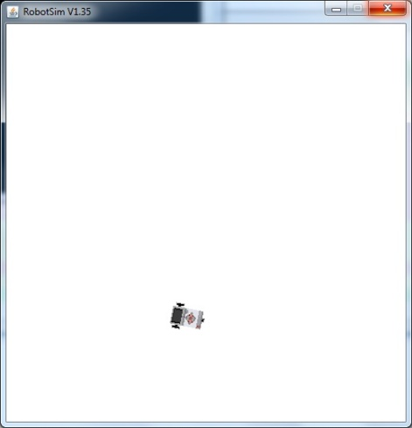

**Practical No :-5**

**Aim :-**Write a program to create a path following robot .

**Program :-**

**PathFinder.java**

import ch.aplu.robotsim.*;

public class PathFinder

{

public PathFinder()

{

NxtRobot robot = new NxtRobot();

Gear gear = new Gear();

LightSensor ls1 = new LightSensor(SensorPort.S1);

LightSensor ls2 = new LightSensor(SensorPort.S2);

robot.addPart(gear);

robot.addPart(ls1);

robot.addPart(ls2);

gear.forward();

while (true)

{

int rightValue = ls1.getValue();

int leftValue = ls2.getValue();

int d = rightValue - leftValue;

if(d > 100)

gear.rightArc(0.1);

if(d < -100)

gear.leftArc(0.1);

if(d > -100 && d < 100 &&rightValue> 500)

gear.forward();

}

}

public static void main(String[] args)

{

new PathFinder();

}

static

{

NxtContext.setStartPosition(250, 490);

NxtContext.setStartDirection(-90);

NxtContext.useBackground("sprites/path.gif");

}

}

**Output :-**

**Initial state :- Intermediate state :-**

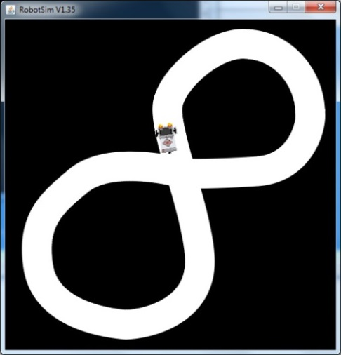



**Final State:-**

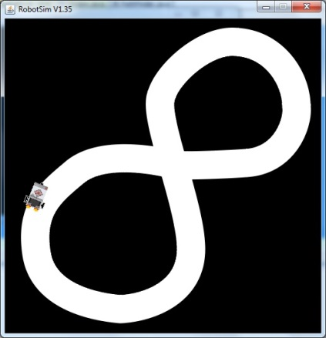

**Practical No :-6**

**Aim :-**Write a program to implement Breadth First Search(BFS) algorithm for a given standard

problem.

**Program :-**

**breadthfirst.java**

import java.util.*;

import java.io.*;

public class breadthfirst

{

ArrayList arr = new ArrayList();

String str[] = new String[2];

String path[] = new String[20];

int i,j,k=0;

public breadthfirst()

{

arr.add("Dadar");

arr.add("Kalyan");

arr.add("Jogeshwari");

arr.add("Malad");

arr.add("Kandivali");

arr.add("Borivali");

arr.add("Goregaon");

arr.add("Andheri");

arr.add("Virar");

arr.add("Bandra");

arr.add("Thane");

arr.add("Bhandup");

arr.add("Mulund");

arr.add("Mahim");

arr.add("Chembur");

}

public void breadth()

{

if(arr.isEmpty())

System.out.println("Empty");

for(i=0;i<20;i++)

path[i]="";

str[0]="";

str[1]="";

System.out.println("\t\t\tDadar\n");

System.out.println("Kalyan\t\t\tJogeshwari\t\t\tMalad\n");

System.out.println("\t\tKandivaliBorivali\tGoregaon\n");

System.out.println("\t\tAndheriVirarBandra\t Thane\n");

System.out.println("\tBhandupMulundMahim\t\tChembur\n");

try

{

BufferedReader br=new BufferedReader(new InputStreamReader(System.in));

System.out.println("Enter the initial node");

str[0]=br.readLine();

System.out.println("Enter the goal");

str[1]=br.readLine();

if(arr.contains(str[1]))

{

System.out.println("Goal is found");

for(j=arr.indexOf(str[0]);j<=arr.indexOf(str[1]);j++)

{

path[k]=arr.get(j).toString();

k++;

}

}

}

catch(IOException e)

{}

System.out.print("Path is: ");

for(j=0;j<k;j++)

{

System.out.print(path[j]);

if(j!=k-1)

System.out.print("-->");

}

}

public static void main(String arg[])

{

breadthfirst b = new breadthfirst();

b.breadth();

}

}

**Output :-**

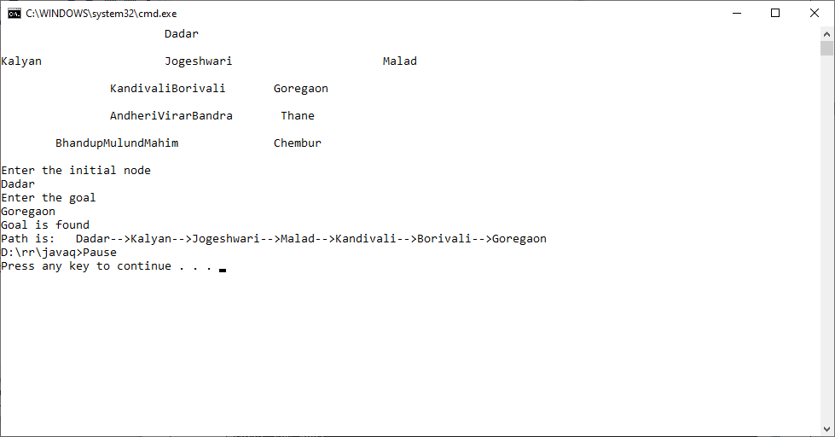

**Practical No :-7**

**Aim :-**Write a program to implement Depth First Search(DFS) algorithm for a given standard

problem.

**Program :-**

**depthfirst.java**

import java.util.*;

import java.io.*;

public class depthfirst

{

ArrayList arr = new ArrayList();

String str[] = new String[2];

String path[] = new String[20];

int i,j,k=0;

public depthfirst()

{

arr.add("Dadar");

arr.add("Kalyan");

arr.add("Jogeshwari");

arr.add("Kandivali");

arr.add("Andheri");

arr.add("Bhandup");

arr.add("Virar");

arr.add("Mulund");

arr.add("Bandra");

arr.add("Borivali");

arr.add("Mahim");

arr.add("Malad");

arr.add("Goregaon");

arr.add("Thane");

arr.add("Chembur");

}

public void depthsearch()

{

if(arr.isEmpty())

System.out.println("Empty");

for(i=0;i<20;i++)

path[i]="";

str[0]="";

str[1]="";

System.out.println("\t\t\tDadar\n");

System.out.println("Kalyan\t\t\tJogeshwari\t\t\tMalad\n");

System.out.println("\t\tKandivaliBorivali\tGoregaon\n");

System.out.println("\t\tAndheriVirarBandra\t Thane\n");

System.out.println("\tBhandupMulundMahim\t\tChembur\n");

try

{

BufferedReader br=new BufferedReader(new InputStreamReader(System.in));

System.out.println("Enter the initial node");

str[0]=br.readLine();

System.out.println("Enter the goal");

str[1]=br.readLine();

if(arr.contains(str[1]))

{

System.out.println("Goal is found");

for(j=arr.indexOf(str[0]);j<=arr.indexOf(str[1]);j++)

{

path[k]=arr.get(j).toString();

k++;

}

}

}

catch(IOException e)

{}

System.out.print("Path is: ");

for(j=0;j<k;j++)

{

System.out.print(path[j]);

if(j!=k-1)

System.out.print("-->");

}

}

public static void main(String arg[])

{

depthfirst b = new depthfirst();

b.depthsearch();

}

}

**Output :-**

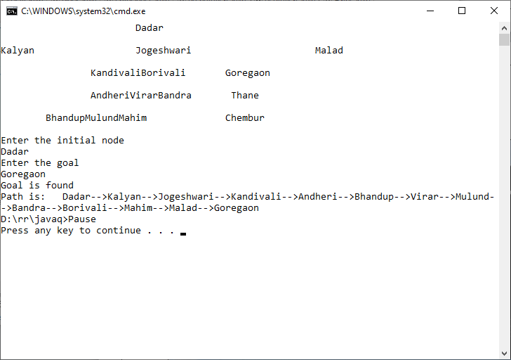

**Practical No :- 8**

**Aim :-**Write a program to implement A* search algorithm for a given standard problem .

**Program :-**

**Astar.java**

import java.util.*;

import java.io.*;

class Astar

{

String str[]=new String[2];

String s1,s2="";

int no,i,j,min=1,temp,k=0;

String path[] = new String[50];

public Astar()throws IOException

{

BufferedReader br = new BufferedReader(new InputStreamReader(System.in));

System.out.print("Enter the initial node:-\n");

str[0]=br.readLine();

path[k]=str[0];

System.out.print("Enter the Goal Node:-\n");

str[1]=br.readLine();

System.out.println("\t\t\tDadar\n");

System.out.println("Kalyan\t\t\tJogeshwari\t\t\tMalad\n");

System.out.println("\tKurla\tKandivaliBorivali\tGoregaon\n");

System.out.println("\tAndheriVirarBandra\t Thane\n");

System.out.println(" BhandupMulundMahim\t\t\tChembur\n");

while(!str[0].equals(str[1]))

{

System.out.print(s2);

System.out.println("Enter the no. of node of" +" "+ str[0] );

s1=br.readLine();

no=Integer.parseInt(s1);

String st[][] = new String[no][3];

int arr[] = new int[no];

System.out.println("Enter the successor nodes of" +" "+ str[0]+" " +"With their straight line distance to goal node h(n) and path cost from start node i.e. h(n) ");

for(i=0;i<no;i++)

{

for(j=0;j<3;j++)

{

st[i][j]=br.readLine();

}

}

for(i=0;i<no;i++)

{

arr[i]=Integer.parseInt(st[i][1])+Integer.parseInt(st[i][2]);

}

for(i=0;i<no;i++)

{

for(j=i+1;j<no;j++)

{

if(arr[i]<arr[j])

{

temp=arr[i];

arr[j]=arr[j];

arr[i]=temp;

}

else

{

temp=arr[i];

arr[i]=arr[j];

arr[j]=temp;

}

}

}

min=arr[0];

for(i=0;i<no;i++)

{

if((Integer.parseInt(st[i][1])+Integer.parseInt(st[i][2]))==min)

str[0]=st[i][0];

s2="Node"+" "+str[0]+" "+"has smallest value therefore ";

}

k++;

path[k]=str[0];

}

System.out.println("The path from initial node to goal node is:");

for(i=0;i<k;i++)

System.out.print(path[i]+"--->");

System.out.print(str[1]);

}

public static void main(String arg[])throws IOException

{

Astar a = new Astar();

}

}

**Output :-**

